## Looking for MLH’s contact info?

You can find Major League Hacking (MLH) on the web in the following places:

* **Web:** <http://mlh.io>
* **Twitter:** [@MLHacks](http://twitter.com/MLHacks)
* **Facebook:** [MajorLeagueHacking](http://facebook.com/MajorLeagueHacking)
* **Email:** [hi@mlh.io](mailto:hi@mlh.io)

If you’re looking to get in touch with the MLH rep onsite (DAWSON!) you can contact me in one of the following ways:

* **Web:** [**DawsBot.com**](https://dawsbot.com)
* **Email:** [**dawsonbotsford@gmail.com**](mailto:dawsonbotsford@gmail.com)
* **Twitter:** [@DawsonBotsford](https://twitter.com/dawsonbotsford)

## Feel unhappy? Unsafe? Harassed?

Harassment and abuse are never tolerated. Major League Hacking hackathons are a safe space for everyone. Read the [Major League Hacking Code of Conduct](http://static.mlh.io/docs/mlh-code-of-conduct.pdf) for more.

Find a Major League Hacking Team Member or get in contact with us over phone or email.

+1 (409) 202-6060 / [incidents@mlh.io](mailto:incidents@mlh.io)

## Want to have some fun?

Need a break from coding? Want to have some fun? Join us for some awesome mini-events! We’ll run *one* of the following activities:

* **Cup Stacking** - This is a fun, engineering based skill game where you and a teammate have to stack the tallest tower of cups. Here’s the catch -- you can only use yourselves and the cups! *No laptop or team required*.
* **!Light!** - This is a frontend coding game. All participants are given the same screenshot of a website and must recreate it to the best of their ability in HTML & CSS. No code completion tools, no syntax highlighting, no compiling your code before 10 minutes. *Bring a laptop!*
* **Slideshare Karaoke** - This is an improv activity where the presenter (you) is given a randomly selected presentation from different presentation that are nonsensical when assembled together or slides are nonsensical on their own. *No laptop or team required.*
* **Werewolf** - This is a group activity. One minute you’re a Villager, defending your theoretical home with every fiber of your being. The next, you’re a Werewolf, framing your friends and accusing them of wanting to destroy your village (when it was you all along). *No laptop or team required*.

## Looking for free Software?

**Want free hosting!?**

Our friends at Amazon Web Services provided all of you up with [$100 in AWS Hosting credit](http://hackp.ac/aws-fall17)! That’s like free money for developers, right!? If you’ve never heard of AWS, they power a *huge* part of the web, including Airbnb, slack, Foursquare, and more!

**Want free domains!?**

Come to the Major League Hacking table to get a free domain code from [Domain.com](http://hackp.ac/domainfall17). Register a free .com, .net, or .org domain today! You’ll also get free whois privacy to protect the domain too.

**Want free tools?**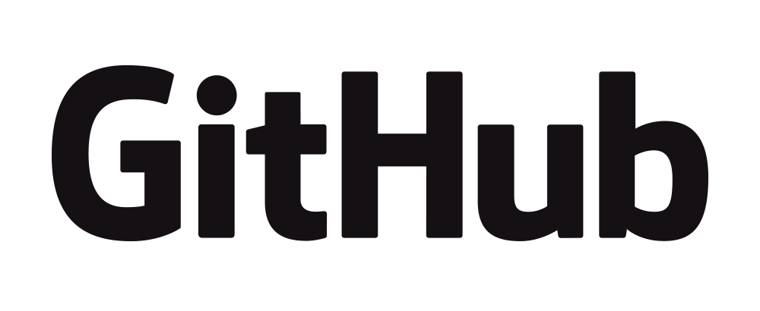

GitHub Education has you covered with the [GitHub Student Developer Pack](http://hackp.ac/githubfall17), thousands of dollars in free technology, courtesy of GitHub and its partners.

**Want free payments API?**

Softheon’s payments API allows you to test your integration without actually charging credit cards. You can access their great [payment platform](http://hackp.ac/softheon-fall17) and get started today!

## How ethical is your approach to technology?

MLH is committed to long-term success and sustainability in the tech world. This season, we're rolling out a new initiative to support Ethical Tech creations at our hackathons to understand the long-term intended and unintended consequences of the great technologies that our community builds. We have a fun quiz that tests hackers' awareness of ethical issues within the tech community. Take the quiz here: <http://hackp.ac/ethicaltech> and receive a **special limited edition sticker** at the MLH table!

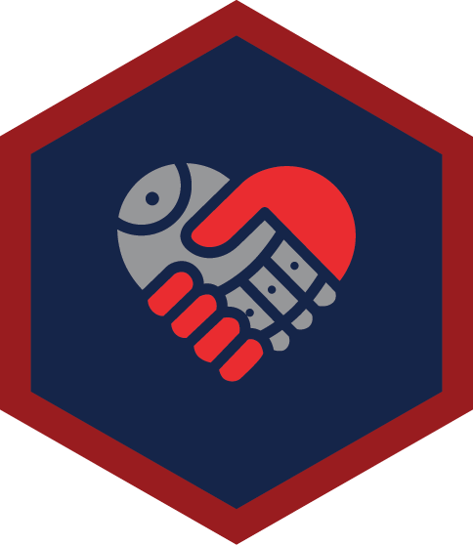

For those of you who submit a project, the “Most Ethical Hack” at the end of the season will win $10,000 to attend a tech conference of their choosing, including travel and expenses to get there!

## Want to supercharge your hack with hardware?

We believe that hackers should have access to the latest and greatest technologies to build on, so we brought a fully stocked *Hardware Lab* for you to use this weekend. It has devices like VR headsets, wearables, and microcontrollers!

**What Hardware is in the Lab?**

* **Amazon Echo** - The Amazon Echo gives your home a voice.

Using this voice controlled speaker you can create all kinds

of amazing hacks. “Alexa make me a hack!”

* **Oculus Rift & Samsung Gear VR -** Interested in working

on a Virtual Reality (VR) hack? We have the new Oculus Rift 

with us and Samsung Gear VRs if you want to develop

something using the phone in your pocket!

* **Qualcomm Device** - The DragonBoard 410C is a 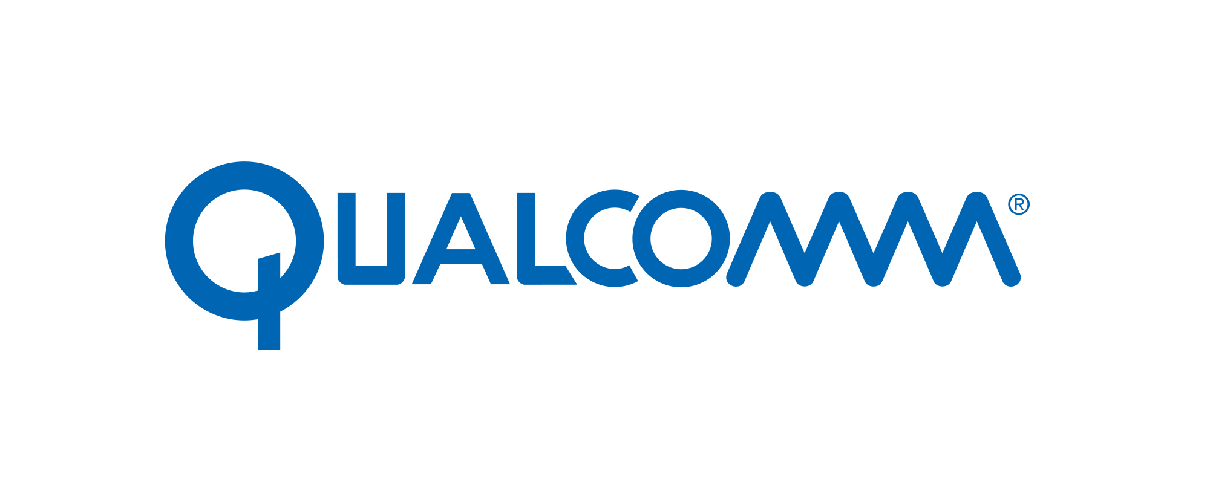

development board based on a Qualcomm Snapdragon

410 processor. Features advanced processing power, Wi-Fi,

bluetooth connectivity, and GPS!

* **So much more!**  - We have a ton of other amazing devices and sensors in the lab. Get a full list by heading over to <http://hardware.mlh.io>.

**How to checkout Hardware:**

1. Head over to <http://hardware.mlh.io>
2. Select the event you’re at from the list
3. Add devices you’d like to use to your cart
4. Submit your request for devices
5. Head over to the hardware lab and hand them your government ID
6. Hack on the devices!
7. When you’re done, bring back the devices and we’ll return your ID.

## Want to win cool prizes?

We brought some super sweet prizes for you this weekend. Here’s what you can win:

* **Top Teams** -Official Major League Hacking Medal for each team member
* **Best Domain Name Registered with Domain.com** - Raspberry Pi & PiHut Essential Kit for each team member
* **Best Internet of Things (IoT) Hack Using Qualcomm Device** - DragonBoard 410C & Power Source for each team member
* **Best Use of Amazon Web Services (AWS)** - $250 Amazon Web Services Credit (US Only) for each team member

## Looking for an internship / job?

Major League Hacking works with some amazing companies that have [incredible career opportunities](http://hackp.ac/careers-for-hackers) for hackers! Visit us at the MLH table to learn about Our Career Partners.

## Collect cool swag!

Hackers love swag and we brought some really awesome swag for you to collect this weekend!

* **Season T-Shirts** - We partnered up with the folks at Capital One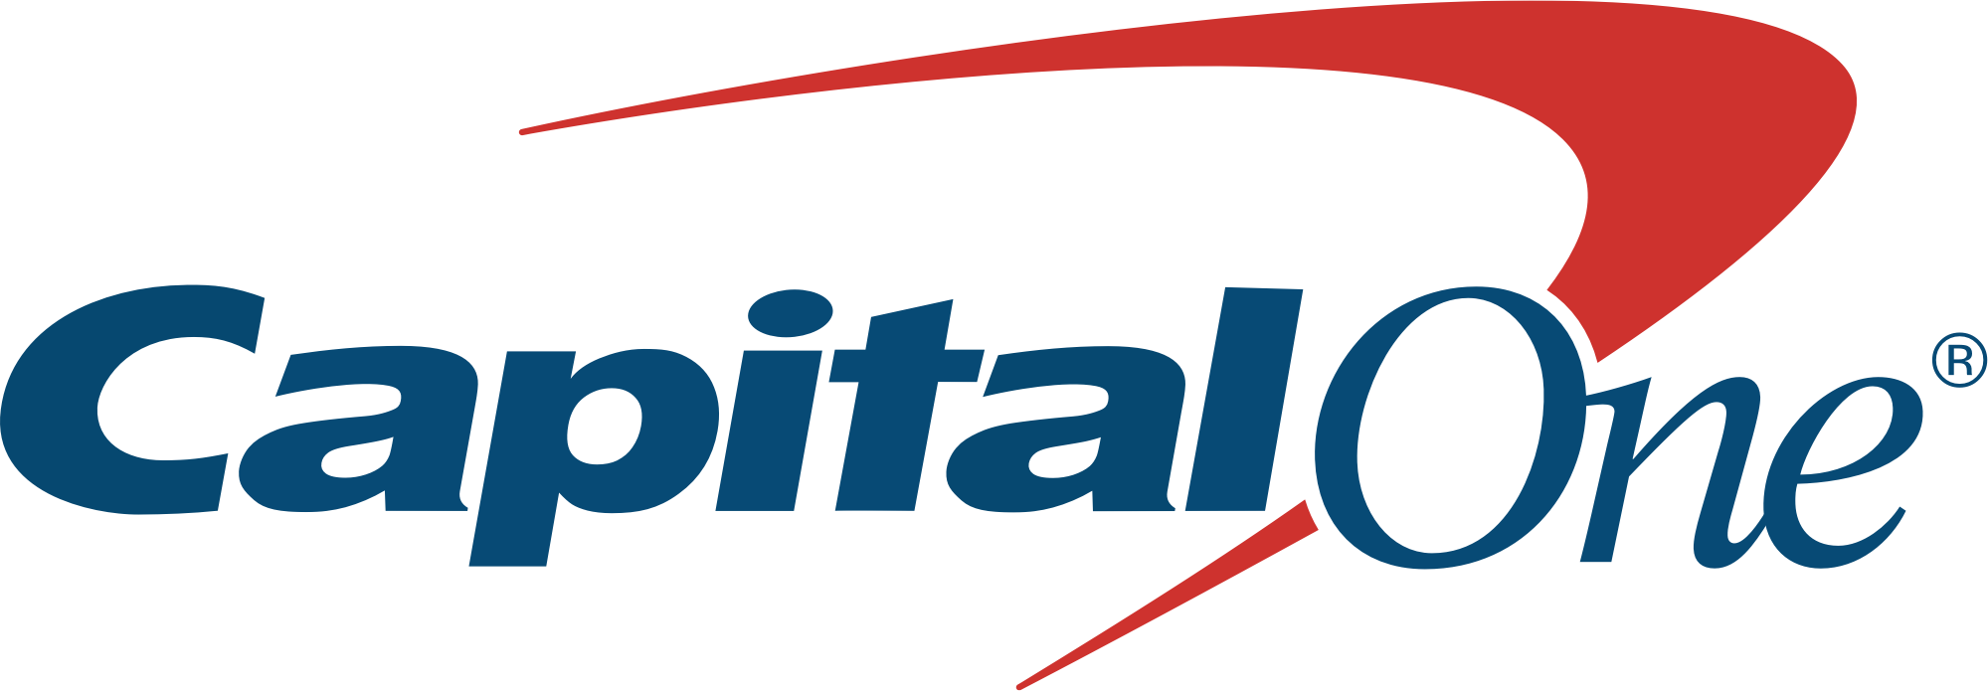

to create these amazing season t-shirts. We’ll be giving them out

this weekend, so make sure you come by the MLH table and

find out when that’ll happen! We have unisex and womens sizes!  
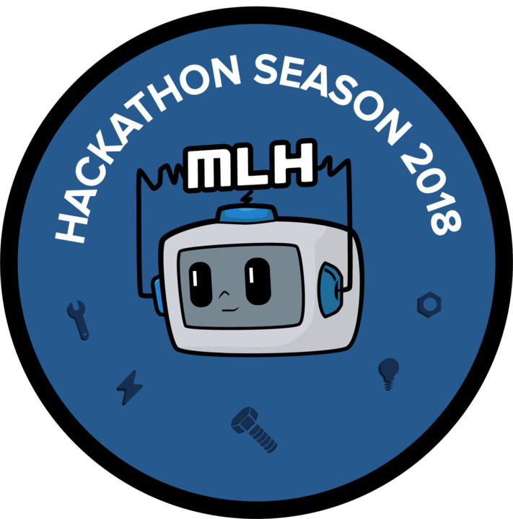

* **MLH Stickers** -We have season and classic MLH stickers

for you to collect at check-in and the MLH table. Swing by

and grab ‘em while they’re still available!

* **“I Demoed” Stickers** -We want everyone to show off the amazing 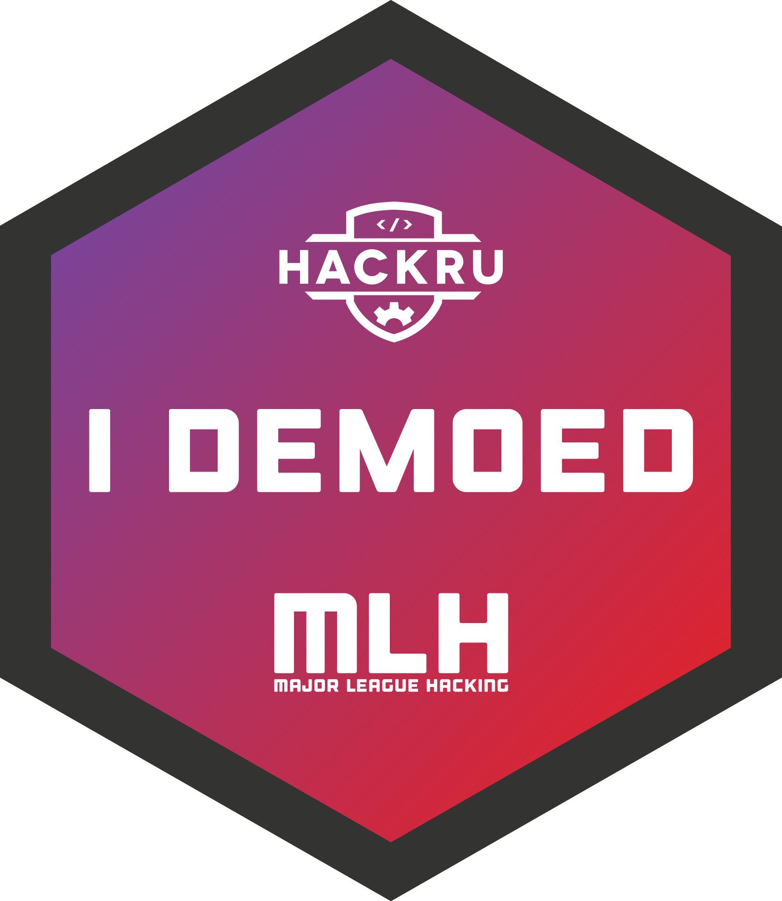

things they build this weekend. Each person who demos gets an

“I Demoed” sticker, which you can collect at every MLH Member

Event you go to! <http://mlh.io/events>

## Missing something?

Looking for something not mentioned here? Come find an MLH representative and ask! You can also reach out to us on social media or hit us up on email ([hi@mlh.io](mailto:hi@mlh.io)).